**ME685A**

**Applied Numerical Methods**

**Assignment - 4**



**Course Instructor: Bhaskar Dasgupta**

**Submitted by**

**AAKASH GUPTA**

**13807003**

**BT – MT Dual Degree**

**DEPARTMENT OF MECHANICAL ENGINEERING**

**IIT KANPUR**

**Question 1**

Trapezoidal rule :- Approximating function f(x) with linear interpolation

|  |  |  |
| --- | --- | --- |
|  | $$\int_{x_{i-1}}^{x_{i}}{f\left(x\right)≈}\frac{h}{2} (f\left(x_{i}\right)+f\left(x_{i-1}\right))$$ |  |
|  | $$\int_{a}^{b}{f\left(x\right)≈}h[\frac{1}{2} (f\left(x_{0}\right)+∑f\left(x_{i}\right) + \frac{1}{2}f\left(x_{n}\right)]$$ |  |

First we conduct trapezoidal integration taking N = 1.

Then we increase the value of N upto 10000, one count at a time.

The error in integral vs step size is plotted below:

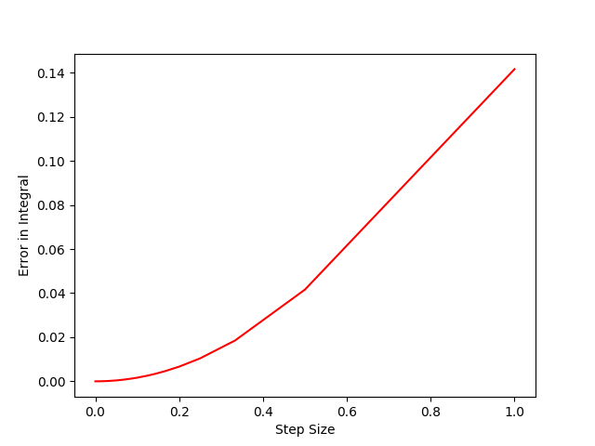

Romberg Integration:-

We improve the accuracy of trapezoidal integration by Romberg's method

J11 = Trapezoidal integration with step size h

J11 = Trapezoidal integration with step size h/2

J11 = Trapezoidal integration with step size h/4

|  |  |  |  |
| --- | --- | --- | --- |
|  | $$J22=\frac{4*J12-j11}{3}$$ | |  |
| $$J23=\frac{4*J13-j12}{3}$$ $$J33=\frac{16*J23-j22}{15}$$ | |

J33 is the answer

Implementing Romberg integration, we get the value as 3.14159265359

From trapezoidal method we get value as 3.14159265357

The analytic integration is π = 3.14159265359

The step size taken was h = 1e-5

We find that Romberg integral is more effective than trapezoidal method

Student's data: -

Here we take the integral

|  |  |  |
| --- | --- | --- |
|  | $$\int_{0}^{1}{e^{x} dx}$$ |  |

The Actual value is 1.71828182846. h used is 1e-5

Results: -

1. By trapezoidal Integration: - 1.71828182847
2. Using Romber integration: - 1.71828182846

**Question 2**

Here we use two point gauss-quadrature for evaluation of the integral

Given integral:

|  |  |
| --- | --- |
|  | $$K\left(x\right)=\int_{0}^{\frac{π}{2}}{\frac{4}{\sqrt{1-x^{2}\sin^{2}{θ}}} dθ}$$ |

We modify the values accordingly to get it in the range (-1,1)

|  |  |  |
| --- | --- | --- |
|  | $$\int_{-1}^{1}{f(t) dt ≈ \sum_{i=1}^{n}{w_{i}}}f(t_{i})$$ |  |

By two point gauss quadrature, we get the weight functions and the Integration points as

|  |  |  |
| --- | --- | --- |
|  | $$\int_{-1}^{1}{f(t) dt ≈ }(f\left(-\frac{1}{\sqrt{3}}\right) + f\left(-\frac{1}{\sqrt{3}}\right))$$ |  |

We plot the integral K(x) as a function of x

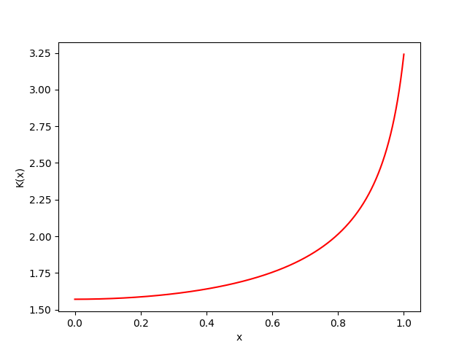

**Question 3**

Given Integral: -

|  |  |  |
| --- | --- | --- |
|  |  | () |

Bringing them in limits -1 to 1, we get

|  |  |  |
| --- | --- | --- |
|  |  | () |

We use simpons formula for integration to get:

I = 1.00349034443

For Integration over a circle

We switch to polar coordinates and we obtain the integrand to be

|  |  |  |
| --- | --- | --- |
|  |  | () |

Between the limits of -1 to 1 for both r and $θ$, we get

I = 0.675708489837

**Question 4**

We have

|  |  |  |
| --- | --- | --- |
|  | $$y^{'}={\left(4x+y-1\right)}^{2} ;y\left(0\right)= -1 ;0≤x≤1$$ |  |

We take h = 0.1 in all cases

Euler’s Method

|  |  |  |
| --- | --- | --- |
|  | $$y_{n+1}= y_{n}+hf(x_{n},y_{n})$$ |  |

Improved Euler’s Method

|  |  |  |
| --- | --- | --- |
|  | $$\overline{y_{n}}= y_{n}+hf(x_{n},y_{n})$$ |  |
|  | $$y_{n+1}= y_{n}+\left(\frac{h}{2}\right)(f\left(x_{n},y_{n}\right)+f(x_{n+1},\overline{y_{n+1}})$$ |  |

**RK4 method: -**

|  |  |  |
| --- | --- | --- |
|  | $$K_{1}=hf\left(x_{n},y_{n}\right)$$ |  |
|  | $$K_{2}=hf\left(x_{n}+\frac{h}{2},y_{n}+\frac{K_{1}}{2}\right)$$ |  |
|  | $$K_{3}=hf\left(x_{n}+\frac{h}{2},y_{n}+\frac{K_{2}}{2}\right)$$ |  |
|  | $$K_{4}=hf\left(x_{n}+h,y_{n}+K_{3}\right)$$ |  |
|  | $$K=\frac{1}{6}(K_{1}+2K_{2}+2K_{3}+K_{4})$$ |  |
|  | $$x_{n+1}= x_{n}+h ; y_{n+1}= y_{n}+k$$ |  |

We solve the ODE using above three methods and plot the graph

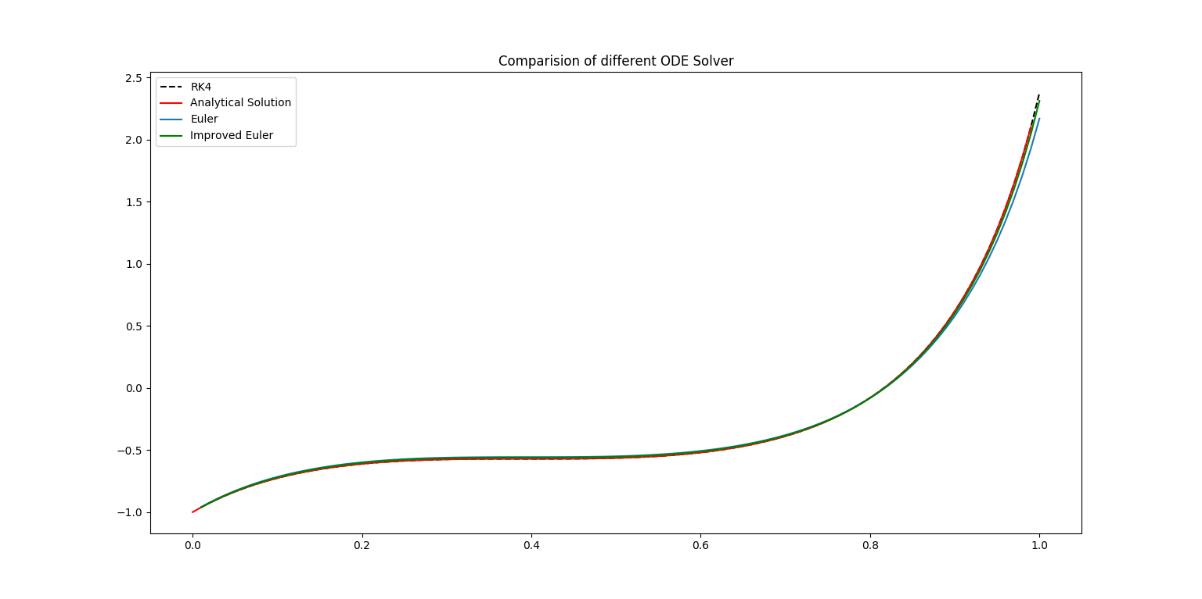

**Question 5**

Lotka-Volterra predator-prey system(y1-> Rabbits y2-> Foxes)

|  |  |  |
| --- | --- | --- |
|  | ${y'}_{1}=ay_{1}-by_{1}y_{2}$ |  |
|  | $${y'}_{2}=cy_{1}y_{2}-dy_{2}$$ |  |

For no change:

|  |  |
| --- | --- |
|  | $${y'}_{1}=0 ; {y'}_{2}=0$$ |

which gives

|  |  |  |
| --- | --- | --- |
|  | $$y_{1}(0), y_{2}(0))= \left(0,0\right) ;\left(0,\frac{a}{b}\right) ;\left(\frac{d}{c} ,0\right) ;\left(\frac{d}{c} ,\frac{a}{b}\right)$$ |  |

We take a=6, b=1, c=2, d=8 and solve the equations using RK4 method for various values of initial conditions

The following graph is obtained for y1(0)=1, y2(0)=100

The phase space obtained for y1(0)= y2(0) = 1.

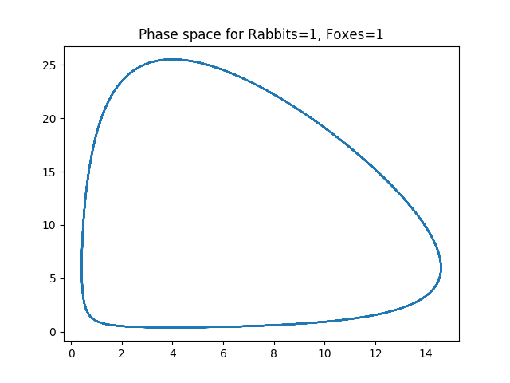

**Question 6**

We have

|  |  |  |
| --- | --- | --- |
|  | $${x'}_{1 }=-k_{1 }x_{1 }$$ |  |
|  | $${x'}_{2}=k_{1 }x_{1 }- k_{2}x_{2}$$ |  |
|  | $${x'}_{3}=k_{2}x_{2}$$ |  |

We obtain the coefficient matrix as

|  |  |  |
| --- | --- | --- |
|  | $$A= \left[\begin{matrix}-k_{1 } & 0 & 0 \\ k_{1 } & - k_{2 } & 0 \\ 0 & - k_{2 } & 0\end{matrix}\right] ;X^{'}=AX$$ |  |

The system becomes stiff as condition number of A increases

For stiff systems, we use Semi Implicit Euler’s Approach

|  |  |  |
| --- | --- | --- |
|  | $$y_{n+1}= y_{n}+h{\left(I-hJ\right)}^{-1}f(x_{n+1},y_{n})$$ |  |

Plots:

1. X1 = 1/2 ; X2 = 2/5 ;X3 = 1/10 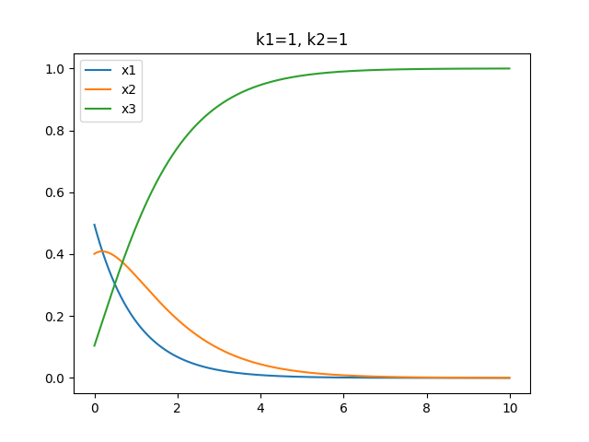
2. X1 =100 ; X2 = 0 ; X3 = 0(student data)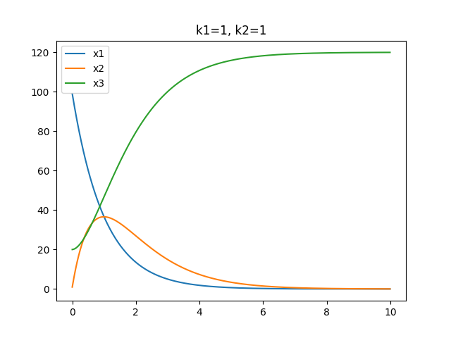
3. Stiff System; x1 = 100; x2 = 0; x3 =0

**Question 7**

The Boundary Value Problem

|  |  |  |
| --- | --- | --- |
|  | $$y^{''}=10y^{3}+3y+t^{2},0≤t≤1$$ | (1) |
|  | $$y\left(0\right)=0 ;y\left(1\right)=1$$ | (2) |

**By shooting Method: -**

We take y'(0) = p and find the error in y(1), so now error is a function of p. So we newton's method to make error zero giving p = 0.472464852127

We now plot y vs x 